G VENKATA SRIDHAR  gvsridhar.devops@gmail.com
+91-9739964629

JENKINS

GIT:
How to install GIT Plugin in JENKINS
- Jenkins Dashboard → Manage Jenkins → Manage Plugins →
Available Tab →Filter in Search → GIT Plugin → Click → Install Without Restart.
Status Check:
- Check in Source Code Management, whether GIT is available (or) not.

GIT Setup in JENKINS
- Jenkins Dashboard → Manage Jenkins → Click on “Configure System”
→ GIT Section (Scroll Down until you see) → Configure.

Manage Users:
How to Manage Users?
- Login Jenkins → Jenkins Dashboard → Select Manage Jenkins →
Select Manage Users (Scroll Down until you see) → Click “Manage Users”

Note: Here we can Create User & Delete User. It will open in another console
- Console →Click Create User → UserName, PWD, Confirm PWD, FullName & Email Address (Fill above all) → Click “Sign-Up”
Status Check:
- After creating user, once Logout and Login.
- Checking in Dashboard Manage Users → Jenkins Dashboard → Click People → Created users available here.

Maven:
How to Download and Install Maven?
- Maven is Java based tool, so the very first requirement is to have JDK installed on your machine.
- Install JDK 1.5 or Above and Add “JAVA_HOME” in Environment Variables.
- Download Maven and Add “MAVEN_HOME” & “M2_HOME”in Environment Variables.
- Once the file downloaded, extract the files to the relevant application folder.

Setting up Jenkins and Maven
- Login Jenkins → Jenkins Dashboard → Select Manage Jenkins → Click “Configure System” (Scroll Down until you see MAVEN Section) → “Add Maven” button →
Un-Check “Install Automatically” Option → Add any name for the setting & the location of the MAVEN_HOME → Click ”Save” button.
Create a job for Maven
- Create a job with the ‘Maven Project’ option. Click on the “New Item”

Manage Plugin:
How to Manage Plugins?
- Login Jenkins → Jenkins Dashboard → Select Manage Jenkins →
Select Manage Plugins (Scroll Down until you see) → Click “Manage Users”

Note: Here we have four options.
- Update – It will show the latest updated version. Now we want to install any update version we can install without restart.
Ex: Previous version is 1.2 & updated version is 1.4
- Available - It will show all available plugins list.
Ex: Before login Jenkins SCM → GIT not Available.
After login, go to available option and go to filter option select or type Git plugin → Click Install without restart.
Status Check:
  - Check in Source Code Management, whether GIT is available.
- Install - It will show all previous and present installed plugins.
- Advanced - For any needed plugin not available in your Jenkins.
Go to google download and choose upload plugin here and one more option is available filter.

EMail:
How to send E-Mail Notifications?
- Login Jenkins → Jenkins Dashboard → Click on “Configure System” →
Select E-Mail Notification (Scroll Down until you see) → Click “E-Mail Notification”
SMTP Server → smtp.gmail.com (No need to change keep it as DEFAULT)
Email Suffix → @gmail.com (No need to change keep it as DEFAULT)

For SMTP Authentication, select “check-box”
Username → User Login with Email
Password → Provide Password
Use SSL → Select Check-Box
SMTP port → 465 Default
Reply-to Address → Give above same email
Charset → UTF-8 Default

Status Check:
- Select Checkbox and test configuration by sending test e-mail. Give email here same as above. After that click test configuration. Check configuration, once you got message as email was successfully send.
Note: We can configure in post-build actions any email after test configuration is success.

Manage Nodes:
How to Manage nodes?
- Login Jenkins → Jenkins Dashboard → Select Manage Jenkins → Select Manage Nodes (Scroll Down until you see) → Click “New Node” (Give a name for the Node, choose the DUMB Slave Option and Click on “OK”).
- Before launch, we need to install ”Power Shell Plugin”.
- Enter the details of the Node Slave Machine. In the below example, we are considering the slave machine to be a windows machine.
- Hence, the option of “Let Jenkins control this Windows slave as a Windows service” was chooses as the launch method.
- We also need to add the necessary details of the Slave Node such as the node name and the login credentials for the node machine. Click ”Save” button.
- The Labels for which the name entered, as “New_Slave” is what can be used to configure jobs to use this slave machine.

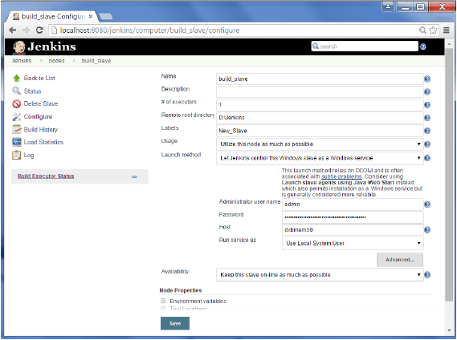

- Once the above steps are completed, the new node machine will initially be in an offline state, but will come online if all the settings in the previous screen were entered correctly. One can at any time make the node slave machine as offline if required.
- After creating a job for node, we need to follow below steps:
- Creating job as a ‘free-style’ and click ‘Save’
- In second console, click ‘checkbox’. Restrict where this project can be run.
- Label Expression → Type ’Slave Name’ here.
- Click ‘Save’ & Check the Build Status.
CRON JOB:
How to Create/Start/Stop/ Etc CRON Jobs?
- CRON Job
- # pwd - Root
- # vi xyz.sh
- Echo “Hello Shree”

- Create CRON Job
- # crontab –e
- # chmod +x /var/spool/cron/root (Or) # chmod 600/var/spool/cron/root

- Start CRON Job
- # crontab /var/spool/cron/root
- # cd /var/log (Check in Logs)
- # cat cron (We can see here running job each minute and check time here)

- Stop CRON Job
- # systemctl stop crond.service (Or)
- # service crond stop
- # pgrep cron

- Check CRON Job is running or not
- # pgrep crond
- # service crond status

- Re-start CRON Job
- # service crond restart
- # service crond status

Discard Old Builds:
Install discard old build plugin.
- Jenkins does not store the builds in the workspace.
- When you configure Jenkins to archive build artifacts, they are copied away from the workspace. These artifacts, build logs, test results are controlled by the Discard Old Builds setting.
- If you have old builds in the workspace, you probably have not set up anything to clean the workspace from files from previous builds. You could check the box under SCM settings to clean the workspace before building. (This setting is in the SCM part of the job configuration because every SCM plugin has their own way of doing it.).
- There is also a delete workspace plugin, which is useful for builds that do not use SCM.

Error: No Workspace
- There is no workspace for this project. Possible reasons are:
- The project was renamed recently and no build was done under the new name.
- The agent this project has run on for the last time was removed.
- The workspace directory (/var/lib/jenkins/workspace/hh) is removed outside Jenkins.
- The workspace was wiped out and no build has been done since then.
- Run a build to have Jenkins create a workspace.

Basic
- After installing this plugin, a new post-build step named 'Discard Old Builds' appears.
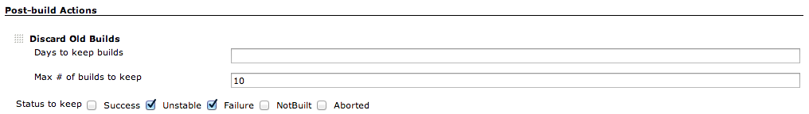
- 'Days to keep builds' and 'Max # of builds to keep' work as same as Jenkins core function.
With checking statuses in 'Status to keep' section, Jenkins will keep the builds with selected statuses.
- Last build / last stable build / last successful build are always kept.
- If all the checkboxes are left unchecked, builds with any status are kept.

Advanced
- In advanced section, you can configure how to treat the builds which are older than the criteria specified in basic configuration.
For old builds, perhaps you do not want to keep all, but sometimes you want to keep some of them with less frequency.

Example 1:
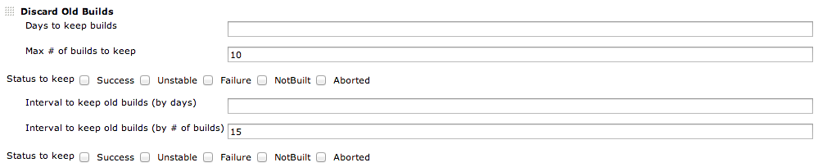
- This configuration shows:
- Latest 10 builds are kept.
- Except for the latest 10, one in 15 builds are kept (#1, #16, #31, etc).

Example 2:
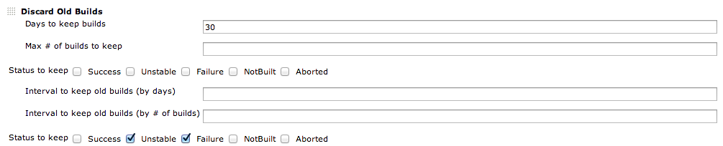
- This configuration shows:
- Builds within 30 days are kept.
- For builds older than 30 days, only builds with unstable/failure are kept.

BACK-UP Manager:
How to Install Back-Up Plugin?
- Login Jenkins → Jenkins Dashboard → Select Manage Jenkins →
Check “Backup Manager” → Click & Find 3 Options.

Note: By using this, we can Back-Up and Restore Jenkins configuration files.

- Back-Up Manager, available in three options:
- Set-Up → Change Directory allows Zip Type & only selected Job types can handle.
- Back-Up → Default Directory, allows Tar.gz and all back-up’s
- Restore → Restore recent backup file and Default Directory.

Metrics & Trends:
How to Install Metrics & Trends Plugin?
- Need to install these 2 plugins, Build History Metrics Plugin & Hudson Global-Build Status Plugin.
- Login Jenkins → Jenkins Dashboard → Select Manage Jenkins → Click Manage Plugins
Go to Filter → Type Above 2 Plugins → Click Install without Restart.

How to check Build History Metrics Plugin is working?
- Need to Configure Job → Click Build → Check the Status (Success or Failure)

Status Check: Jenkins Dashboard → Click “Build History” → It will show Map History.

How to check Hudson Global-Build Status Plugin is working?
- After installation plugins, under “Manage Jenkins” will see “Global Build Status”
- Global Build Stats → To Display Daily Build Stats.

Status Check: Jenkins Dashboard → Select Manage Jenkins → Click “Global Build Stats” →
Under Statistics → Create “New Chart Configuration” (It will show some options, we need to fill depends on required) → Finish → Click Overview

Build Periodically:
How to check Build Periodically?
Only check manual running without adding github.com URL
- Create Job → Give Job Name → Select “Free-Style” Project → Click OK
- Select Build Periodically → Give CronTab Job SCM → Add Code or Not → Click SAVE
- Click Build Now → Check Job Scheduling for your CronTab.

Jenkins - Continuous Deployment:
- Jenkins provides good support for providing continuous deployment and delivery. If you look at the flow of any software development through deployment, it will be as shown below.

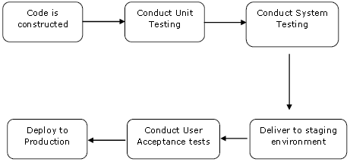

- The main part of Continuous deployment is to ensure that the entire process, which is shown above, is automated. Jenkins achieves all of this via various plugins, one of them being the ”Deploy to container Plugin” which was seen in the earlier lessons.

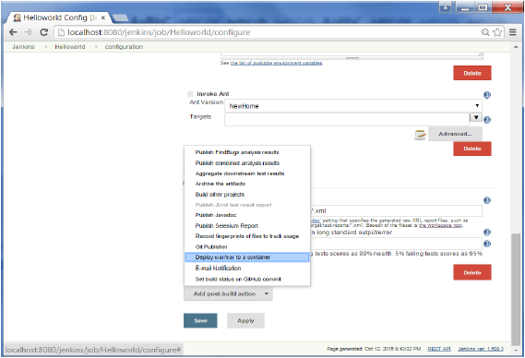

- There are plugins available, which can actually give you a graphical representation of the Continuous deployment process. But first lets create another project in Jenkins, so that we can see best how this works.

Create a simple project
- Which emulates the QA stage, and does a test of the HelloWorld Application.
- Step 1: Go to the Jenkins dashboard and click on New Item. Choose a ”Freestyle Project” and enter the Project Name as ‘QA’. Click on the Ok button to create the project.

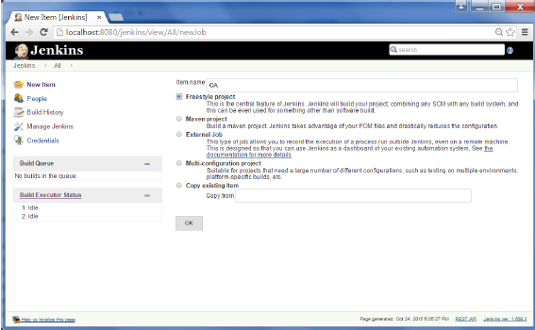

- Step 2: In this example, we are keeping it simple and just using this project to execute a test program for the HelloWorld Application.

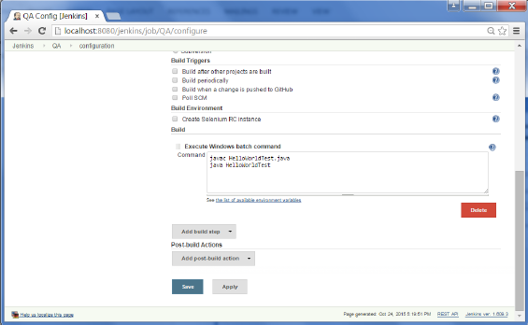

- Therefore, our project QA is now setup. You can do a build to see if it builds properly.
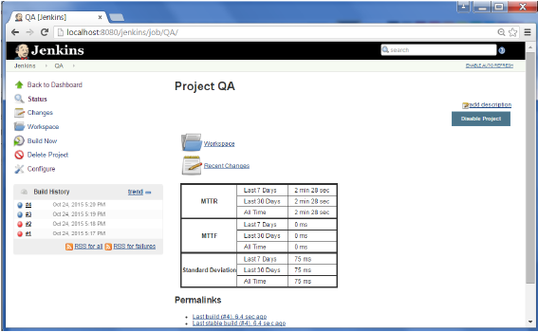

- Step 3: Now go to you HelloWorld Project and click on the “Configure” option
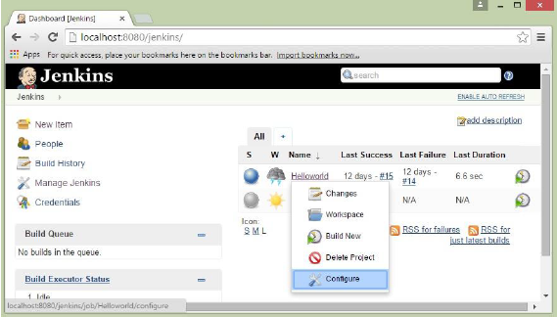

- Step 4: In the Project Configuration, choose the ”Add Post-Build Action” and choose ”Build Other Projects”.
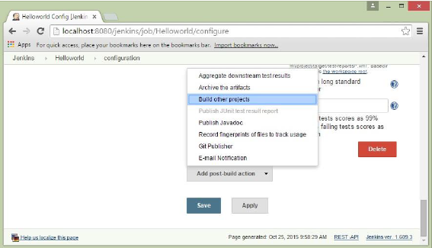

- Step 5: In the ”Project to Build” section, enter QA as the project name to build. You can leave the option as default of ”Trigger only if Build is Stable”. Click on the Save button.

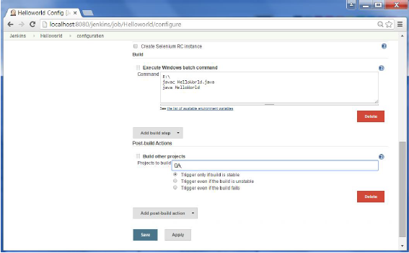

- Step 6: Build the HelloWorld Project. Now if you see the Console output, you will also see that after the HelloWorld Project is successfully built, the build of the QA project will also happen.

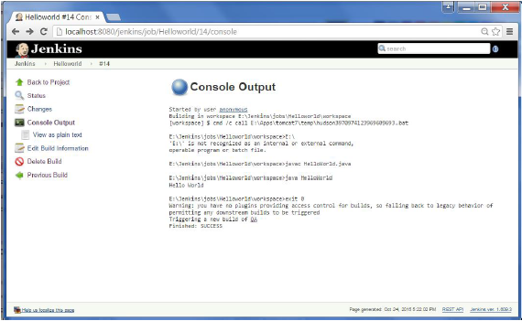

- Step 7: Let now install the Delivery pipeline plugin. Go to Manage Jenkins → Manage Plugin’s. In the available tab, search for ’Delivery Pipeline Plugin’. Click On Install without Restart. Once done, restart the Jenkins instance.

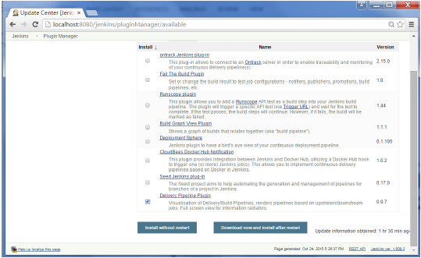

- Step 8: To see the Delivery pipeline in action, in the Jenkins Dashboard, click on the
“+” symbol in the Tab next to the ‘All’ Tab.
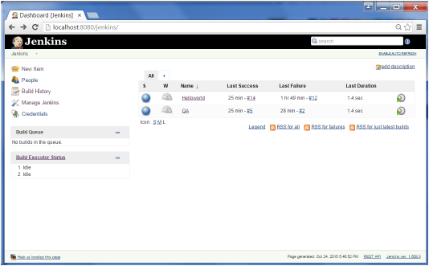

- Step 9: Enter any name for the View name and choose the option ‘Delivery Pipeline View’

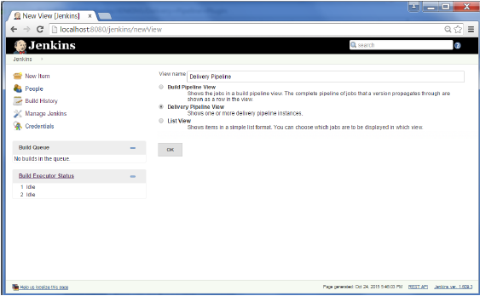

- Step 10: In the next screen, you can leave the default options. One can change the following settings −
- Ensure the option ‘Show Static Analysis Results’ is checked.
- Ensure the option ‘Show Total Build Time’ is checked.
- For the Initial job – Enter the HelloWorld Project as the first job which should build.
- Enter any name for the Pipeline
- Click the OK button.
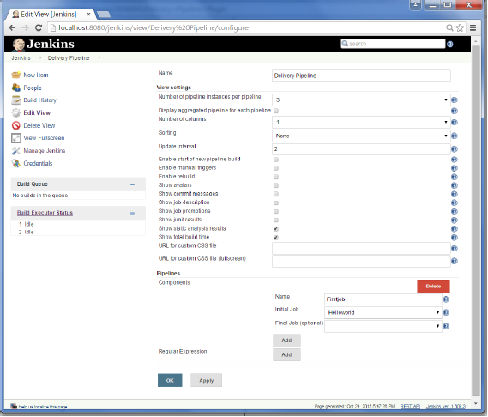

- You will now see a great view of the entire delivery pipeline and you will be able to see the status of each project in the entire pipeline.
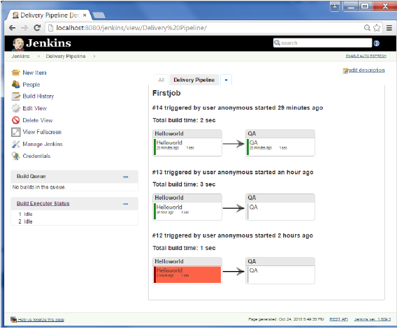

- Another famous plugin is the ”Build Pipeline Plugin”. Let’s take a look at this.
- Step 1: Go to Manage Jenkins → Manage Plugins. In the available tab, search for ”Build Pipeline Plugin”. Click On Install without Restart. Once done, restart the Jenkins instance.

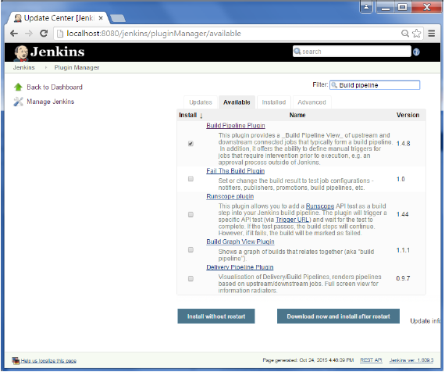

- Step 2: To see the Build pipeline in action, in the Jenkins Dashboard, click on the + symbol in the Tab next to the ‘All’ Tab.
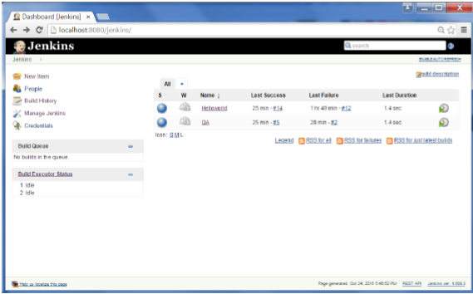
- Step 3: Enter any name for the View name and choose the option ‘Build Pipeline View’.

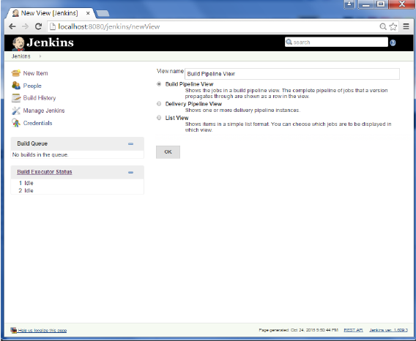

- Step 4: Accept the default settings, just in the Selected Initial job, ensure to enter the name of the HelloWorld Project. Click on the Ok button.

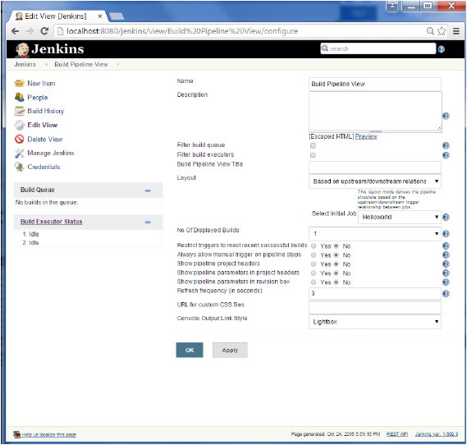
- You will now see a great view of the entire delivery pipeline and you will be able to see the status of each project in the entire pipeline.
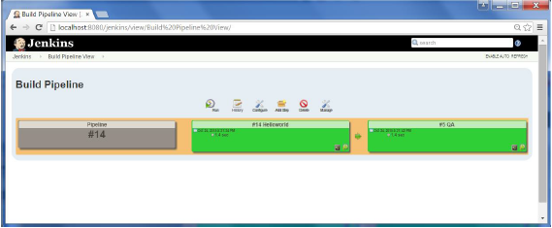

Jenkins Security:
- In Jenkins, you have the ability to setup users and their relevant permissions on the Jenkins instance. By default, you will not want everyone to be able to define jobs or other administrative tasks in Jenkins. Therefore, Jenkins has the ability to have a security configuration in place.
- To configure Security in Jenkins, follow the steps given below.

- Step 1: Click on Manage Jenkins and choose the ‘Configure Global Security’ option.

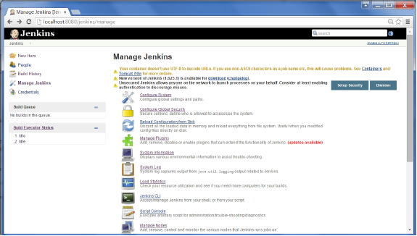

- Step 2: Click on Enable Security option. As an example, let us assume that we want Jenkins to maintain its own database of users, so in the Security Realm, choose the option of ‘Jenkins Own User Database’
- By default, you would want a Central Administrator to define users in the system, hence ensure the ‘Allow Users to SignUp’ option is unselected. You can leave the rest as it is for now and click the Save button.
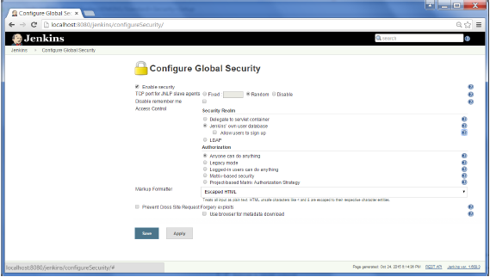

- Step 3: You will be prompted to add your First User. As an example, we are setting up an admin users for the system.

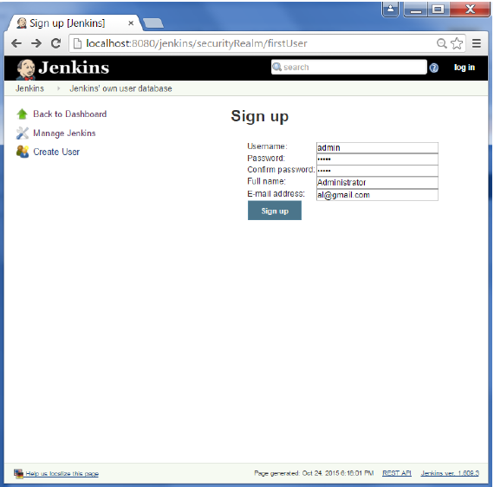
- Step 4: It is now time to setup your users in the system. Now when you go to
Manage Jenkins → Scroll Down, you will see ‘Manage Users’ option → Click this option.

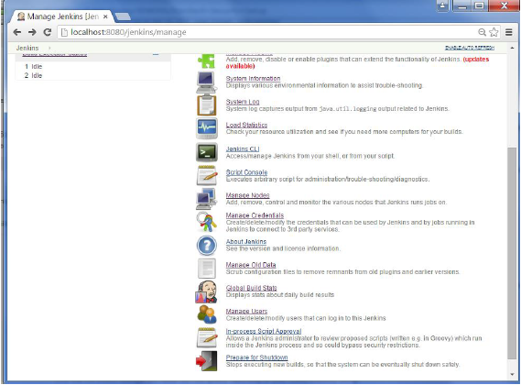

- Step 5: Just like, you defined your Admin User, start creating other users for the system. As an example, we are just creating another user called ‘user’.
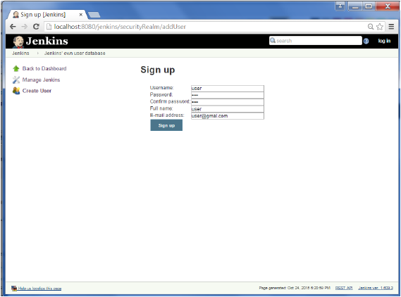

- Step 6: Now it is time to setup your authorizations, who has access to what.
Go to Manage Jenkins → Configure Global Security → Now in Authorization Section → Click on ‘Matrix Based Security’.
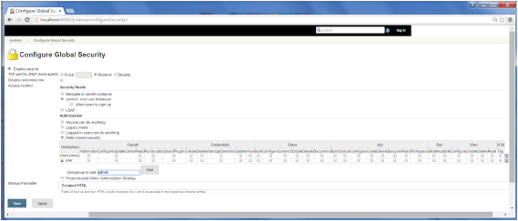
- Step 7: If you do not see the user in the User Group List, enter the user name and add it to the list. Then give the appropriate permissions to the user.
Click on the Save button, once you have defined the relevant authorizations.
Your Jenkins security is now setup.
Note: For Windows AD authentication, one has to add the Active Directory Plugin to Jenkins.

Jenkins – Automated Deployment:
- There are many plugins available, which can be used to transfer the build files after a successful build to the respective application/web server. On example is the “Deploy to container Plugin”. To use this follow the steps given below.
- Step 1: Go to Manage Jenkins → Manage Plugins → Go to the “Available Section” → Find the plugin ”Deploy to Container Plugin” → Install Plugin → Restart the Jenkins Server.
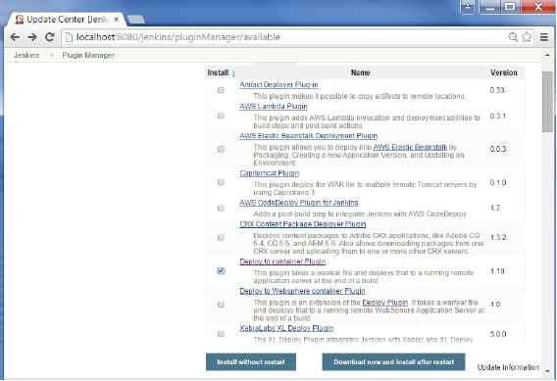
- This plugin takes a War/Ear file and deploys that to a running Remote Application Server at the end of a build.
- Tomcat 4.x/5.x/6.x/7.x
- JBoss 3.x/4.x
- Glassfish 2.x/3.x

- Step 2: Go to your Build project and click the Configure option. Choose the option “Deploy war/ear to a container”
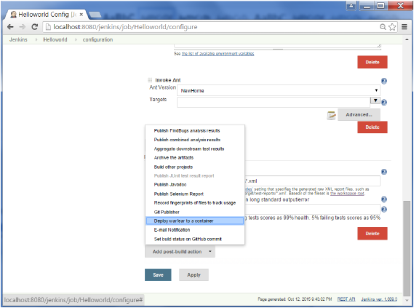

- Step 3: In the Deploy war/ear to a container section, enter the required details of the server on which the files need to be deployed and click on the Save button. These steps will now ensure that the necessary files are deployed to the necessary container after a successful build.
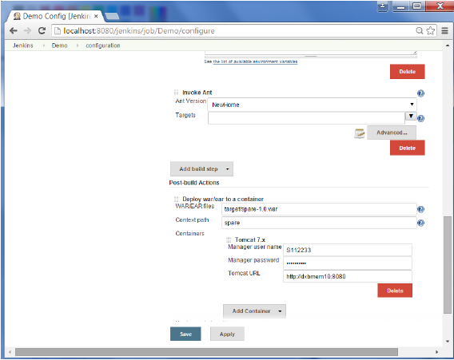
JAR/WAR/EAR:
JAR File (Java Archive)
- JAR file is as WinZip file compressed with JDK software. The problem of popular WinZip file is it should be unzipped on Windows OS only. WinZip is platform-dependent.
- A WinZip file cannot be opened or unzipped from Linux. For that matter, all zipping algorithms are platform-dependent.
- The interesting point with JAR file is it can be zipped and unzipped by JVM irrespective of OS. That is, wherever Java is working, the JAR file can be created or unzipped. It can be said, JAR is platform-independent way of creating a zip file.
- A JAR file extension is .jar and is created with jar command from command prompt (like javac command is executed). Generally, a JAR file contains Java related resources like libraries, classes etc.; but need not be. It can contain any non-sense (non-related) files like .txt, .doc, .gif etc., just like a WinZip can contain.
- All the options of JAR command, security aspects, creating JAR file with unzipping are discussed with examples at JAR (Java Archive) Files.

WAR File (Web Application Archive)
- A WAR file is simply a JAR file but contains only Web related Java files (but not Web unrelated files) like Servlets, JSP, HTML, Database Java Beans, web.xml file, Property bundles, JavaScript, shopping carts etc. necessary to develop Web applications.
- The advantage of WAR file is it can be deployed easily on client machine in a Web server environment. The extension of WAR file is .war but of course created with JAR command only.
- To execute a WAR file, a Web server or Web container is required, for example, Tomcat, WebLogic, or WebSphere. To execute a JAR file, simple JDK is enough.
- The IDE tools like Eclipse, JBOSS etc. maintain a directory hierarchy structure for WAR files like WEB-INF folder etc.
- Two programs are given on the creation of WAR file.
- Servlet WAR File in Tomcat with Creation, Deployment, and Execution.
- Servlet WAR File in WebLogic Creation and Deployment.

EAR File (Enterprise Application Archive)
- EAR file contains Enterprise application related files (J2EE) like XML, EJB modules etc. It is also created with JAR command only but with extension .ear. EAR file is deployed in an application server.
- Advantages JAR, WAR and EAR files
- With JAR, WAR and EAR files, the deployment of software is easy on client machines. At a stretch all, the related files of an applications are installed. For example, Oracle comes with JAR files for distributing Oracle database on CDs etc. IBM uses JAR for installation and documentation for WebSphere.
- Easy development and testing

- Disadvantages
- Making minor changes in a Servlet, JSP or EJB requires complete process of remaking and redeployment of jar, war, ear files. It is very tedious to follow the complete process in dynamic environments where data changes very often.

Jenkins and Deployment Pipelines:
- In the previous post, I described deployment pipelines and mentioned how you need a controller to drive software releases through each stage of the pipeline. This component is typically a Jenkins CI/CD server, although Jenkins’ built-in capabilities to capture pipelines of deployment activity are rather limited. There is an open source Build Pipeline plugin that gets the job done, for the most part. Other commercial tools in this area include: Atlassian Bamboo, ThoughtWorks Go, and XebiaLabs XLRelease.
- This is a screenshot from the Jenkins Build Pipeline plugin that shows various pipelines in progress.

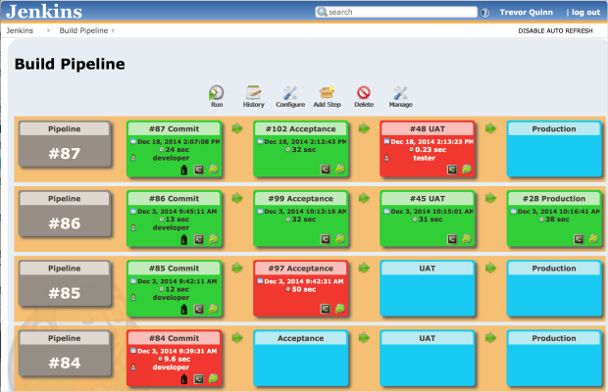

- It helpfully color codes the status of each stage of each pipeline, and, combined with Jenkins itself, allows you to do role-based access to control how and when jobs are launched and restarted. Most importantly, it allows you to capture a flow of build jobs, from stage to stage. Stages can be configured to automatically begin based on successful completion of the stage preceding it or they can require manual push button approval to proceed.

The Build Pipeline tool enables us to capture each of the deployment stages shown below:
Commit Stage
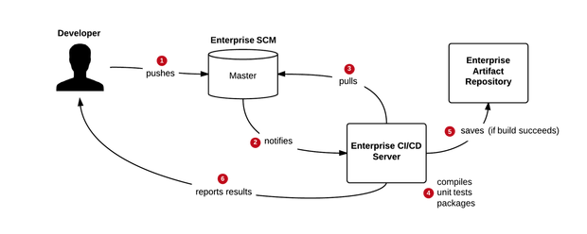
- The Commit Stage is a continuous integration step, used to validate a particular code commit from a compilation, unit test, and code quality standpoint. It does not involve any deployment to an environment, but does include export of a compiled binary (in the case of a Java project) to an enterprise artifact repository such as Nexus.

Acceptance Stage
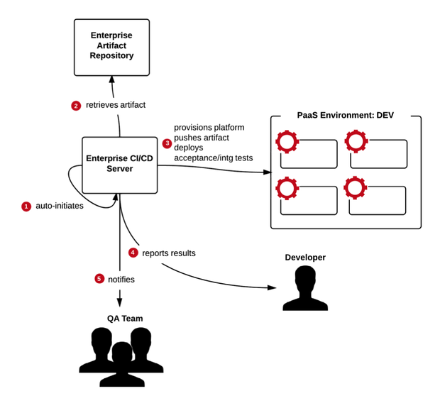
- The Acceptance stage is where automated functional acceptance and integration tests are performed. To do this, Jenkins will deploy the code to an environment. PaaS makes this trivial, as I will shown in a later post.

UAT Stage
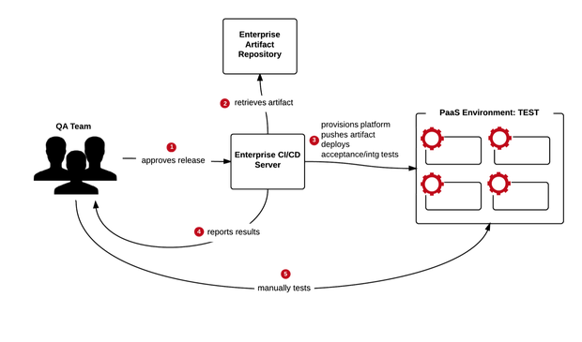
- In this deployment pipeline example, a separate UAT stage is available for manual user testing, important for confirming application usability. Advancement to the UAT Stage must be approved by the QA team, who log in to Jenkins to perform a push button deployment.

Production Stage
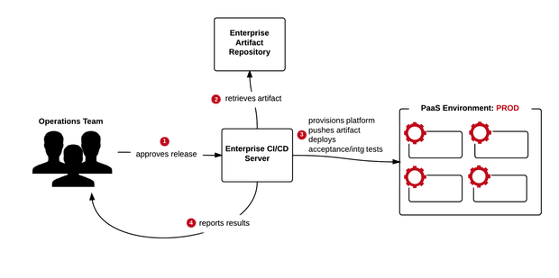
- Release to production is the final stage, controlled by the Operations team. Like the two stages before it, it also involves CI/CD server deployment to the PaaS environment. So that captures the deployment pipeline’s integration with the Jenkins CI/CD server. The next post will profile how the CI/CD server leverages PaaS to make both environment creation, configuration, and application deployment an easy process.

Jenkins Install in Linux:
- Yum update
- Yum install java
- Yum install wget
- sudo wget -O /etc/yum.repos.d/jenkins.repo http://pkg.jenkins-ci.org/redhat-stable/jenkins.repo
- sudo rpm --import https://jenkins-ci.org/redhat/jenkins-ci.org.key
- sudo yum install Jenkins
- sudo service Jenkins start
- sudo service Jenkins status
Jenkins Selenium Plugin Install:
- Step 1: Go to Manage Plugins.
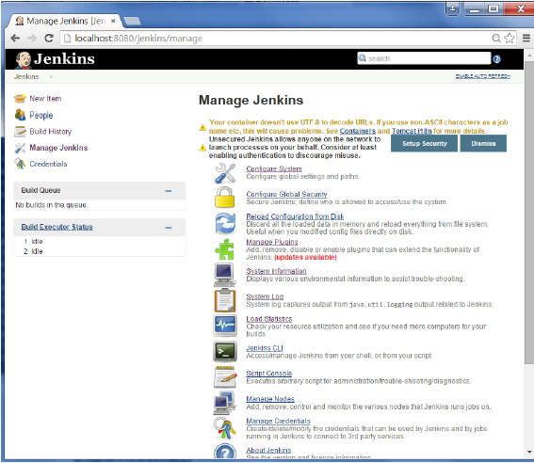

- Step 2: Find the “Hudson Selenium Plugin” → Choose to Install. Restart the Jenkins instance.
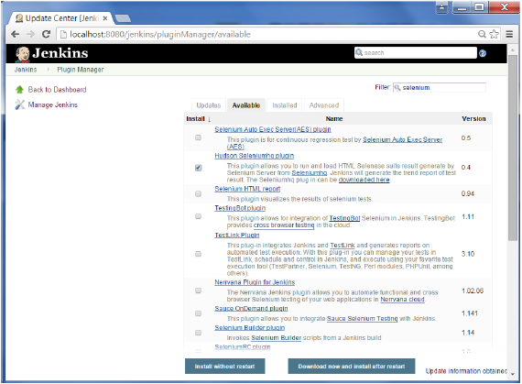
- Step 3: Go to Configure System.
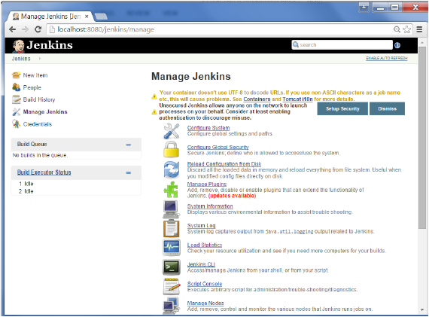

- Step 4: Configure the “Selenium Server Jar” → Click on Save button.
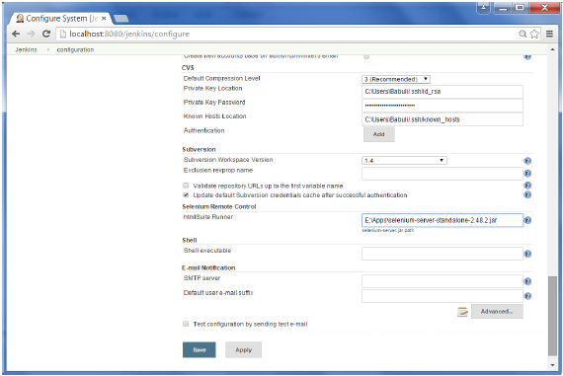

- Note: The selenium jar file can be downloaded from the location SeleniumHQ
Click on the download for the Selenium Standalone Server.

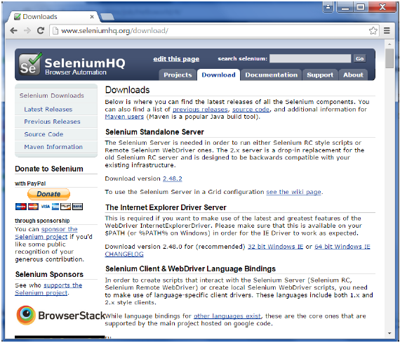

- Step 5: Go back to your dashboard → Click on the Configure Option for the HelloWorld Project.
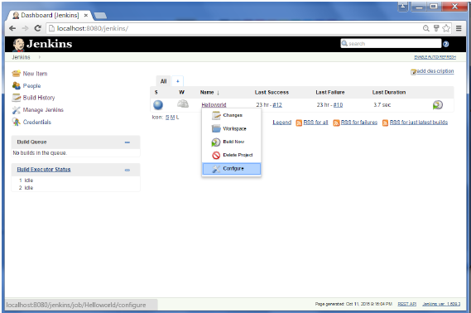
- Step 6: Click on Add Build Step → Choose the option of “SeleniumHQ htmlSuite Run”
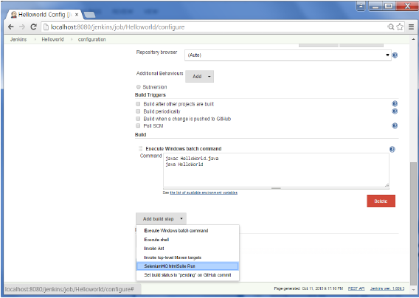

- Step 7: Add the necessary details for the Selenium Test. Here the suiteFile is the TestSuite generated by using the Selenium IDE. Click on Save and execute a Build. Now the post build will launch the selenium driver and execute the html test.

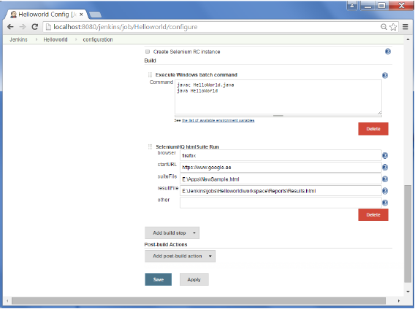

Poll SCM Periodically:

How to make a Jenkins job to Poll SCM Periodically
- Before run Poll SCM → We need to Install POLL SCM Plugin
- Go to configure page of a project.
- Go to “Build Triggers” section.
- Check “Poll SCM”.
- Enter the schedule that you want in cron-style.
- The help that placed side of input area might be useful. Example for poll at every 15minutes is 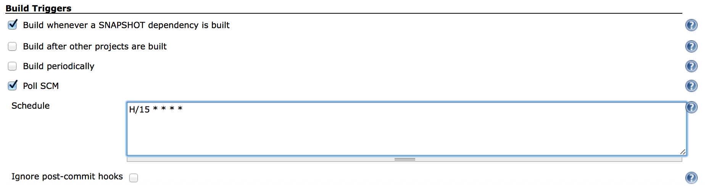

Links:
- http://www.guru99.com/maven-jenkins-with-selenium-complete-tutorial.html
- http://www.vogella.com/tutorials/Jenkins/article.html

